Top Jet Turbines

ECU* Version 36_0 2.1.2020

User manual

Thank you very much for your decision, to get and use the TJT ECU control unit.

* Electronic Control Unit

Index

Top Jet Turbines 1
ECU* Version 36_0 2.1.2019 Nr. 36 1
Index 2
Attention 3
Warning! 3
Liability and damage 3
Terms of warranty 4
Safety Directives 4
General operation of the electronic control 5
Display 5
Power supply 6
Installation of the TJT ECU. 6
Function 8
Measure 8
Control 8
Preparation and verification of the transmitter. 8
Programming the ECU with the Hand data terminal (HDT). 9
Turbine start 9
Turbine Stop 9
Menu 10

Attention

When the TJT ECU & turbine are put into use a number of safety precautions have to be observed. Be aware this aggregate is a REAL one and not a toy. Improper handling might cause danger. It is of great importance to read the manual carefully and to obey strictly all given directives.

The ECU & turbine need regular maintenance for you own safety and the safety of your fellow men. The aggregate is manufactured according to EU rules.
To avoid errors when the TJT ECU and turbine are put into use for the first time, it is strongly recommended to obtain supervision by someone with experience in the field of jet-turbines.

Warning!

Before the ECU & turbine are put into use you have to be acquainted with all the facts concerning the legal regulations on this matter.
Keep other persons at a safe distance from an operating turbine. This means a distance of minimal 4 meters from the front and the back of the turbine and minimal 7 meters from the sides.
The TJT ECU and turbine have been developed exclusively for application in radio controlled aircraft models and must not be used for any other purposes.
The use of non-original parts and/or materials and also any unauthorised modification have to be avoided.

Prior to the start of a model all functions have to be checked.

Liability and damage

For TJT it is quite impossible to verify users compliance with all directives concerning the installation, the operation, the use and the maintenance of the ECU & turbine.
This entails that under no circumstances TJT can be hold responsible for damage, consequential damage and costs as possible result of improper use of the turbine. This involves TJT in no obligation whatsoever to indemnify these costs.
The liability of TJT in case of a material fault is explicitly restricted to the highness of the purchase price.

By using the TJT ECU & turbine the user accepts that TJT cannot possibly verify nor guard the fulfilment of the directions regarding the installation, the safety and the operation of the turbine. When the turbine is put into use this takes places under sole and total responsibility of the user.
From the side of TJT no other commitments are made about the general operation of the turbine, the warranty or any other convention but those mentioned in this manual.

Terms of warranty

Within 12 months after purchase a malfunctioning TJT aggregate will be repaired or defective parts will be exchanged free of charge, if faults in material or manufacturing have been established.
All other responsibilities are excluded: transportation, packing, insurance, eventual travelling costs or any other incidental expenses must be paid by the user.
In case of a warranty claim the aggregate has to be accompanied by the bill of purchase and also a description of the fault.

As a consequence of improper handling of the ECU & turbine or a crash with the model in which the ECU and turbine were installed, open the aggregate, mechanical damages, all warranty rights will end instantaneously.

Safety Directives

- Use adequate hearing protection when operating the turbine.
- Do not operate the turbine in a room without sufficient ventilation.
- Do not keep your hand in front of a running turbine. The suction in this area can result in severe injury to your hand or fingers by the inlet compressor.
- Do not keep your hand near the outlet of a running turbine. Very high temperatures may occur in this area.
- From a safety point of view no persons are allowed to be within a range of 4 meters at the outlet side of a running turbine.
- Always have a fire extinguisher on hand.
- Keep foreign objects as cleaning clothes or other small or light matters at a fair distance away from the inlet opening of the turbine. It might ruin the compressor if sucked in.
- During installation of the turbine in the model the inlet and outlet openings should be sealed.
- The fuel, kerosene (A1) must be mixed with 5% synthetic oil.
- Prior to the start of the turbine the model shall be held in vertical position (nose up) for a moment, to make sure no surplus of kerosene is present in the combustion chamber of the engine.

A turbine powered aircraft model can achieve very high speeds. Pay attention to reduce throttle shortly after take-off. Full power should only be applied during take-off or vertical climb.

General operation of the electronic control

TJT Turbines are controlled by the automatic control electronic include:
1. ECU (Electronic control unit)
2. GSU (Ground support unit), (HDT Hand Data Terminal), or Transmitter

ECU is in the aircraft with the turbine.
GSU serves as an input/output unit adjusting the ECU, and is not necessarily
to be placed in the aeroplane. Not needed by Transmitter control.

Add 1. ECU is control-electronic-unit used to:
- Turbine start
- Receive signals from the sender and takes interfacing between turbine and pilot true
- Control all allowed values (RPM, temperature…) and limits.

Add 2.GSU serves as an input/output unit adjusting the ECU.
Using a real time operating system is possible to adjust parameters, even if the turbine is running. The terminal can be plugged in, even the ECU is turned on.
All controlled values can be displayed on the Transmitter by wireless mode.

Display

Screen appears first when starting (switched on/off ECU and receiver) the HDT and shows the main parameters of operation of the engine, if it is not served by the Transmitter.
The representation of the screen is in 2 rows as follows:

1st row left: RPM Turbine (in 1000th steps)
1st row right: Temperature (If K-Type-Sensor is properly fitted ☺)
2nd row left: Version, “Stop Pilot”, or Pump Voltage
2nd row middle:Time from power on of the ECU (max. 16h.), or Number of Runs.
2nd row right: Voltage of the battery 10 – 12,5 V (NiCad, NiMhd), (3 cells LiPo)

Measure instruments:

Temperature Sensor K Type Thermocouple
Temperature Range: 0-999 ºC.
Temperature Resolution: 2 ºC
Temperature Precision: 2%
RPM range: 0-250.000 /min
RPM Resolution: 10/min, display 1000 /min
RPM Precision: 0.05 %
Pump Battery value Voltage Range 10-12,5 V
Voltage Measure Resolution: 0.1 V
Voltage Measure Precision: 2 %

Power supply

Receiver Battery Voltage: 4,5 up to 6V dependent on fabricate.
Receiver Battery power: 30 mA.
Pump, Starter Battery Voltage: 10 – 12,5 V (NiCad, NiMhd), (3 Cells LiPo)
Pump and Starter: 6 A Max. Continue. 50A Peak
ECU Mechanical measures: 90x56x12 mm
ECU Weight: 45 g. Connectors, Cables and Cover Include

Installation of the TJT ECU.
Connections:
Throttle input to the receiver: JR type servo cable.
Start valve and Fuel valve: JR type connector
Smoke device:JR type connector receptacle
JR type connector receptacle. The central cable is positive and the two of the sides negative.
RPM sensor: JR type connector receptacle
Thermocouple: JR type connector receptacle (properly fitted ☺)
Battery input: Red/black cable
Fuel pump: Red/black cable thin (Twin)
Glow plug: Red/black cable thick, Red is connected to Turbine.
Starter: Red/black cable
Note: In all power cables the red is the common and positive. This means that all the red cables are connected internally together and to the positive of the pump/starter battery.
Connect all of the cables in his places. Note that some of the JR type connectors used can be connected in wrong place or inverted.
Use the coloured labels on the ECU body to connect all the connectors in his place. The configurations of the pins have done in the way that no damage can be produced to the electronics in the case of a bad connection.

Please note that:
· If the thermocouple connector is connected inverted, the temperature will decrease when heated ☺! and the ECU will fail in to recognise the gas ignition.
· If the RPM sensor is connected inverted, no RPM will be read.
· Use the recommended starter motor and battery. If bigger voltages are used, then the high current from the motor can damage the ECU. If after a start attempt you feel that the ECU becomes warm, this is a sign that something is wrong.
The ECU stay cold all the time.
· The glow plug positive cable is connected to the engine body. This means that the whole turbine is connected to the positive of the pump battery. Take this into account if you plan to connect the negative any other place.

Reversing the polarity of the battery causes the destruction of the semiconductors of the ECU.

1st Power on to ECU, and then will be connected power to the receiver. !

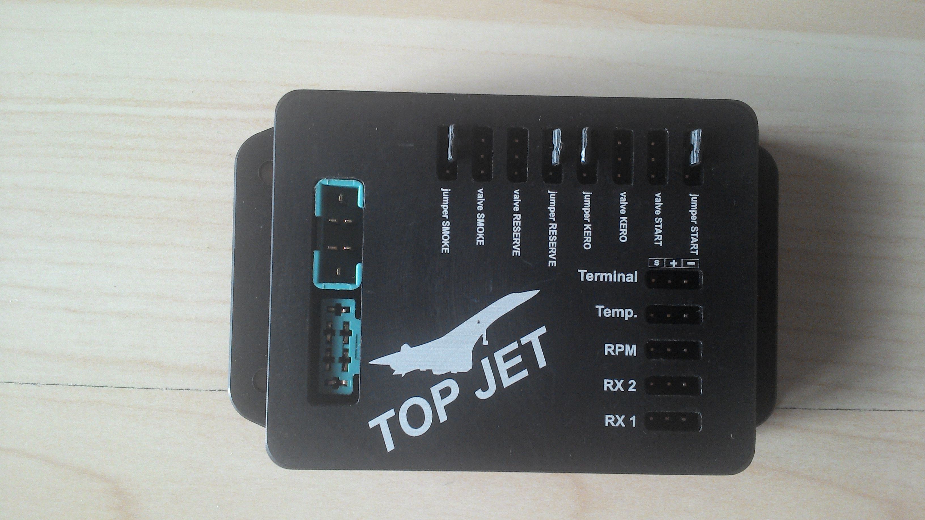
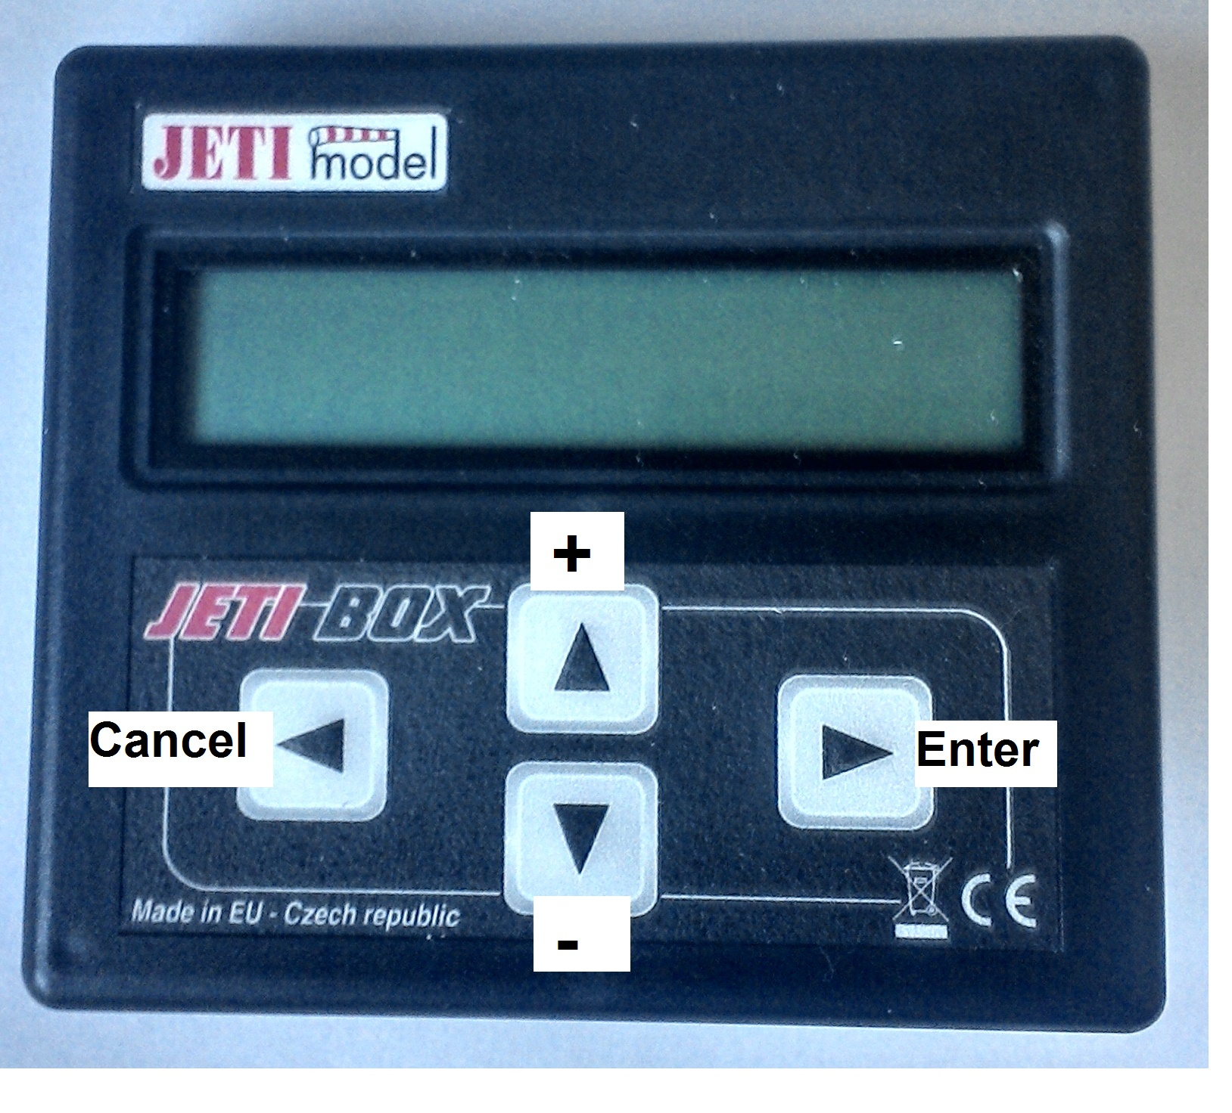

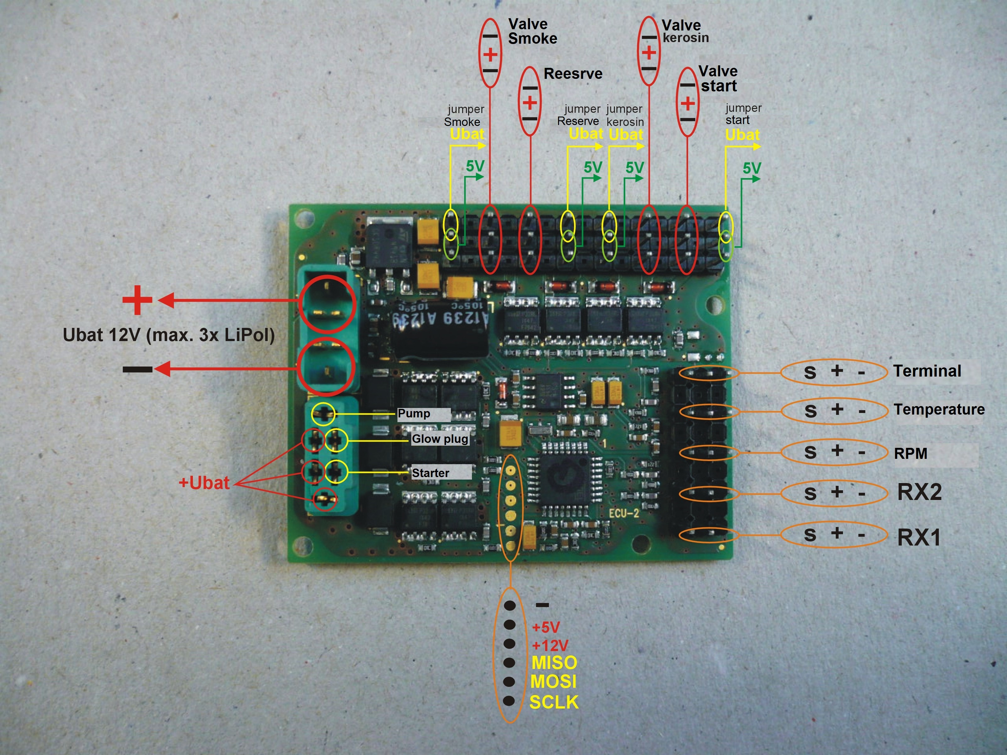

Connector RX2 is for Servo, and work parallel with fuel valve.

Function

Measure

Values continuously measured or showed:

RPM
Temperature of the output cone
Position of the transmitter throttles stick.
Help channel of the transmitter
Voltage of the Output to Pump
Voltage of the Battery
Time from switch on / Number of Runs
Voltage of the glow plug
Maximal reached Temperature and RPM of all.

Control

At first, the transmitter throttle stick range must be defined.
The pump power will be adjusted automatically, dependent to - transmitter throttle stick position. This position is pointed the RPM control.
Minimum and Maximum Pump Voltage values will be adjusted automatically dependent to RPM in the Range of 10.000 RPM (from Max.RPM).

Preparation and verification of the transmitter.

The transmitter must not have programmed any reduction of throw, trim, slow movement, the centre value or the linearity modified. In case of doubt it is recommended to connect a servo to verify that the movement is correct from end to end and fast.
With the trim and stick of the transmitter raised (Full power) the reading of 2nd row left
"Pulse = xxxx” must be between 1900-2200.
With stick and the trim lowered, the reading must be between 800 and 1000.
In case that the readings are inverted, like in some Futaba transmitters,
it is necessary to change the sense of the movement in the transmitter.
(Servo reverses). If the reading does not arrive at these values means that the transmitter has some function of limitation of throw applied to the throttle channel. Once verified the transmitter, the ECU can be programmed.

Programming the ECU with the Hand data terminal (HDT) or Transmitter.

The HDT has a LCD with 16 characters x 2 rows and four buttons which allow you to move through the various menus and to change the data settings in each menu page. The presentation of data has been organised in 2 rows, no display switch is needed
The displays of the engine status readings in real time and the following screens allow you to modify the operating parameters as above table.
All of the parameters can be modified while the engine is running, so it is easy to tune the engine without having to start it again to test the new settings.
The two buttons allow you to move through the different screens in an ascending mode (Menu +) or descending mode (Menu -). The other two buttons allow you to accept entered values or cancel operation.

- Clear (cancel) to the left, (Terminal)
- Minus down, (Terminal)
- Plus Up, (Terminal)
- Enter to the right, (Terminal)

Turbine start

Automatic start will be activated:
1. „Trim“ to Maximum
2. „ Throttle stick ” to Maximum
3. „ Throttle stick” to Minimum (until arriving at idle)

Start Gas heating:
Short Pump start (0,2 Sec)
On display is “Start”
ECU switches the Starter and glow plug on, opens the Gas Valve, and by lowering RPM gas ignition occurs. (Fuzzy logic)
By defect of the glow plug is displayed “*glow” (Start continue)
Start Kerosene heating:
Short Pump start (0,2 Sec), ECU switches glow plug on
On display is “Heating” +- 7 sec.
ECU switches the Starter on, and opens the Start Valve, and waiting before kero ignition occurs.
By defect of the glow plug is displayed “*glow” (Start End, Start Limit G sign.)
When the system detects the ignition has occurred, it starts the starter motor at full power and the pump power is increased during the fuel ramp until arriving at idle

Once on Idle, ECU gives control to Pilot. On display is “Auto”.
Throttle stick must be on Minimum! Otherwise ECU does NOT give the Control over.

Turbine Stop
Pilot cans Stop the turbine by raising Throttle stick and Trim to minimum.
On Display is „Stop Pilot“
The engine stops automatically in case of „out of range“ (Temperature, RPM, lost signal)
On Display is „Stop limit X“ and ECU must be switched off (power off), On, for new Start
(This is for security reason)

Where „X“ =
L If the rotor falls below RMP under run (Menu 5),
H Run the rotor more RPM (Menu 7)
G Not Glow plug Voltage for ignition of gas/Kero
F Flame out by start
Message “*glow” can be also low Battery reason

Menu

Parameters for change by user:

- * Pump Voltage
- * Rx Out (Stop)
- * Rx Idle
- * Rx Full power
- RPM Out(Stop)
- RPM Idle
- RPM full power
- Ramp 2 (from Idle to full power)
- Pump Start (Pump Voltage)
- Pump min (Pump Voltage)
- Pump max (Pump Voltage)
- Ramp 1 (from Zero to Idle)
- Temperature by Start
- Temperature max.
- Ramp slow down to idle
- Gas/Kero opening in %
- * Number of Impulse/RPM
- Glow plug power
- * Factory setting
- * Test Driver
- Factor Temperature correction
- * Select Kero – Gas start condition (gas=1, kero=2)
23. Display max. RPM of all
24. Max. Temperature of all
- Minimum smoke Temperature
- Number of the ECU
- RPM shut down Start Valve and Glow plug
- RPM shut down starter
- * Select Turbine Mark
- U-Min. Starter (V)
- U-Max. Starter (V)
- Fuel Servo out (msec), connected on RX2
- Fuel Servo max.( msec) connected on RX2
- Fuel consumption
- Number of Runs (Total)
- Max. Pump Voltage by max. RPM

* Parameter can not be changed by running turbine – press Cancel

1. Manual Pump operation

Once Menu number 1 is selected press “Enter” Button to run the Pump.
Stay pressing Enter → Kerosene Valve is open+ pump is running
Using button + or - decrease or increase the kerosene flow. (0,2 – 5)
TJT standard: 0,9

2. RX (Transmitter signal) stop

„Turbine stop“ signal recognition does stop Pump and closes Kerosene valve+Servo on RX2 .
To adjust this Parameter – Stick to minimum and Trim in the middle.
To take over the actual transmitter value – press Enter 2-3 times (to get middle value). Pressing „Plus“ or „Minus“ adjust the value manually.
Cancel closes the Operation
TJT standard: 0,800

3. RX (Transmitter signal) Idle

„Turbine Idle“ signal recognition will be used to Adjust Idle RPM.
To adjust this Parameter – Stick to minimum and Trim to maximum.
To take over the actual transmitter value – press Enter 2-3 times. Pressing „Plus“ or „Minus“ adjusts the value manually.
This Value must be larger, than Turbine stops (Menu 2)
TJT standard: 1,000

4. RX (Transmitter signal) Full power

„Turbine full power“ signal recognition will be used to Adjust full power RPM
To adjust this Parameter – Stick to maximum and Trim to maximum.
To take over the actual transmitter value – press Enter 2-3 times. Pressing „Plus“ or „Minus“ adjust the value manually.
This value must be larger, than Turbine Idle (Menu 3)
TJT standard: 2,000

5. RPM under run

If the rotor falls below RMP under run, ECU does emergency stop.
ECU displays “Stop limit L” (by Trim and Stick minimum) Power must be disconnected !
TJT standard: 25.000 O/min

6. RPM Idle

Turbine Idle RPM can be adjusted with this parameter.
TJT standard: 37.000 O/min

7. RPM maximum

RPM at full power (Maximum RPM) Run the rotor more RPM, then this value, emergency stop follows. If you set (after the first Run) the Value down, set the value Menu 11 down too.
ECU displays “Stop limit H” ” (by Trim and Stick minimum)Power must be disconnected !
TJT standard: 115.000 O/min

8. Acceleration ramp

This Parameter is to correct acceleration of the Turbine from Idle RPM to full power.
Value is without dimension. Higher value results in faster acceleration.
TJT standard: 10-40

9. Pump start Voltage

Voltage used for the pump to start. Many pumps have very different operations parameters.
To get a shorter time for first runs, it is necessary to know, which what voltage the pump starts fuel support. Voltage is depending on kind of Pump. 0,2 – 10
TJT standard: 0,9 V

10. Pump min. Voltage

Voltage used for the pump Idle RPM flow. Many pumps have very different operations parameters.
To get a shorter time for first runs, it is necessary to known, with voltage the pump has for fuel support by Idle RPM. This value will be adjusted automatically at the first run.
TJT standard: 0,5 - 10 V

11. Pump max. Voltage

Voltage used for the pump Full power RPM flow. Many pumps have very different operations parameters.
To get a shorter time for first runs, it is necessarily to known, with voltage has the pump for delivery of fuel by full power. This value will be adjusted automatically at the every run.
The automatic adjustment is functional in the range of max.RPM +-5.000 only !
Advise is to set this value not very high e.g.. 3.0 V. By setting max.RPM down, (after the first run) this Value must be set down to 3.2 (pump dependent 1,5 – 12 V)
TJT standard: 3,2 V

12. Pump ramp 1 by start

This Parameter will be used to correct acceleration of the Turbine. From start (0 RPM) to Idle RPM
Value is without dimension. Higher value results in faster acceleration. 1 – 30
TJT standard: 5

13. Temperature by Start

This value will not be used for Ignition detection, but only for the cooling.
( Ignition is detected automatic by ambient + 15 degr.C),
After run try ECU get the temperature less then this parameter.
TJT standard: 100 ºC

14. Temperature max.

Normally operation of the turbine is up to 600-750 ºC on output cone.
Temperature “out of range”(outside this parameter) provokes by up to +100 Degr.C.
decriesing of the max. RPM with 3000,. By more, then 100 Degr.C. an emergency stop
of the Turbine.
Display shows (by trim in minimum position) “TStop limit” Power must be disconnected !
TJT standard: 850 ºC

15. Slacken ramp

This Parameter is to correct slow down of the Turbine from full power to Idle RPM.
Value is without dimension. Higher value results in faster R.p.m. Reduction.
TJT standard: 10-50

16. Gas opening in %

Gas (Kero) opening in % by Start
Cold Weather 100%, Warm Weather 70%
TJT standard: 100%

17. Number of Impulses /RPM

Dependent on usemethod to measure the RPM, optical method needs 2, and magnetic
method 1 pulse.
TJT standard: 1

18. Voltage of the Glow plug

Glow plug Voltage for ignition of gas/Kero. By 8 cells, or Lipo, LiFe the value should be different. Value is without dimension
Lipo 3 cells Gas start - Up to 1,4 – 2,5 Units, Kerosene start 6 – 12,5 V. Range 1,4 – 12,5
TJT standard: 1.5

19. Factory setting

After all this playing with the buttons everything is totally changed, and nothing works any more ☺.
Pressing Plus and Minus (at the same time) load Factory settings back to original.
“Menu” is on Display

20. Test Driver

Test driver runs manual by pressing button:
Minus – Start, kerosene valves and Servo on RX2 are open
Plus - Starter is running
Enter - Glow plug (Heating element)

21. Correction of the thermometer

K-Type Thermometer adjust less then 00 → minus, larger then 00 → plus
Value is without dimension
TJT standard: 00

22. Select Kerosene or Gas Start

Select 1 = Gas Start , 2 = Kerosene Start,
Value is without dimension
TJT standard: 1

23. RPM max. of all

Maximum RPM of all runs.
Can not be changed!
TJT standard: 115000 O/Min

24. Max. Temperature of all

Maximum Temperature of all runs.
Can not be changed!
TJT standard: 850 ºC

25. Min. Smoke Temperature

Minimum Temperature for smoke device
TJT standard: 500 ºC

26. Number of the ECU

The ECU's must become a Number, By more ECU's in System, The Transmitter must correct
identify Data from each ECU.
TJT standard: 1

27. RPM shut down Start Valve and Glow plug

Run the rotor more RPM, then this value, the Start Valve will be closed, and
the Glow plug is out. (Kerosene Start) 5.000 – 20.000 RPM
TJT standard: 15.000

28. RPM shut down Starter

Run the rotor more RPM, then this value, the Starter become shut down
TJT standard: 21 (000)

29. Select Turbine

1 “ TJT K-Typ Sensor"
2 "Frank Turbines"
3 "90er-165000rpm "
4 "T15 "

By Others the parameters must be set by hand.
TJT standard: 1

30. Select U-min Starter

This Parameter is for min. starter power by ignition start (V) Kerosene Start
TJT standard: 3,2

31. Select U-max. Starter

This Parameter is for max. starter power by start (V) Kerosene Start,
TJT standard: 12,6

32. Select Servo Position 1

This Parameter defines edge position 1 of the servo (dependant on direction of rotation)
(Servo connection on RX2 connector for mechanical kerosene Valve ) This one run parallel with the Kerosene Valve
TJT standard: 1200/ 1800

33. Select Servo Position 2

This Parameter defines edge position 2 of the servo (dependant on direction of rotation)
(Servo connection on RX2 connector for mechanical kerosene Valve ) This one run parallel with the Kerosene Valve

TJT standard: 1800 / 1200

34. Select Fuel consumption

This Parameter view the actual fuel consumption
Calibration: Takes 1L fuel, run motor, if after running display do not show 1L,
change the Value . Next Run will be OK.
TJT standard: 0

35. Number of Runs

This Parameter view Number of Runs (Total)
Can not be changed!
TJT standard: 0

36. Pump max. Voltage by max. RPM

The automatic adjustment voltage used for the pump by Full power RPM – 2000.
The Turbine go to Idle RPM and then to max. RPM, and back to Idle.
The Voltage of the Pump by max. RPM will be stored, and this value will be used
by RPM regulations. After function is the value reset to 0.
Display “Init”
Value is without dimension. On = 1
TJT standard: 0

